[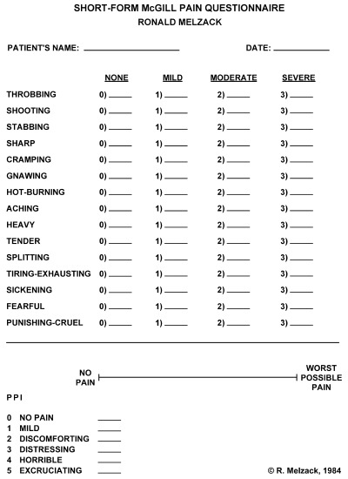](https://www.google.com/url?sa=i&rct=j&q=&esrc=s&source=images&cd=&cad=rja&uact=8&ved=0ahUKEwjI3t_mhtLUAhUK5mMKHWgOAt8QjRwIBw&url=https%3A%2F%2Fwww.researchgate.net%2Ffigure%2F10834107_fig2_Figure-1-The-short-form-McGill-Pain-Questionnaire-SF-MPQ-Descriptors-1-11-represent&psig=AFQjCNHnudAHAfAXAtzhvzeIxAKJ1QB49A&ust=1498241529334453)