GRANT COUNTY LCAC MEETING SITE LOCATION 1:

John Day Fire Hall
316 S Canyon Blvd
John Day, OR 97845

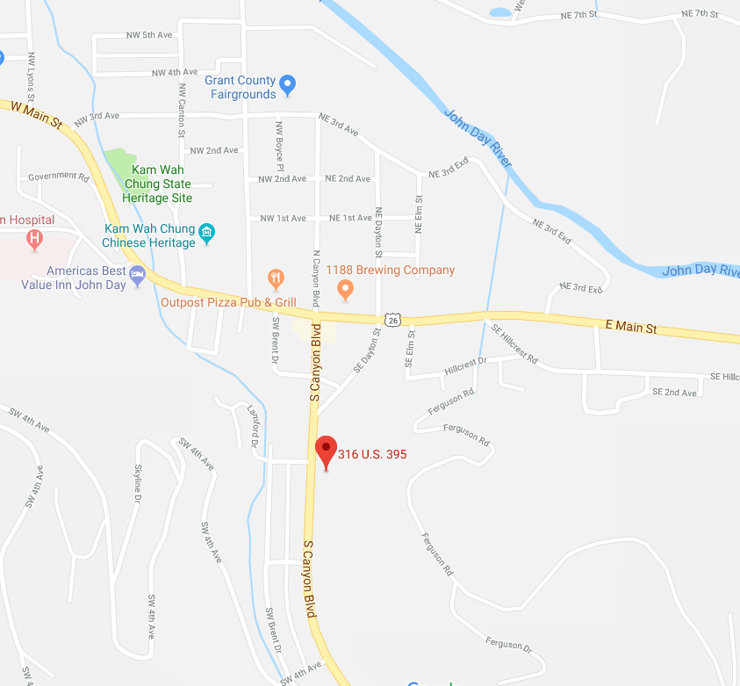

OR

OTHER SITE USED FOR GRANT COUNTY:

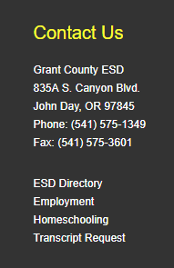

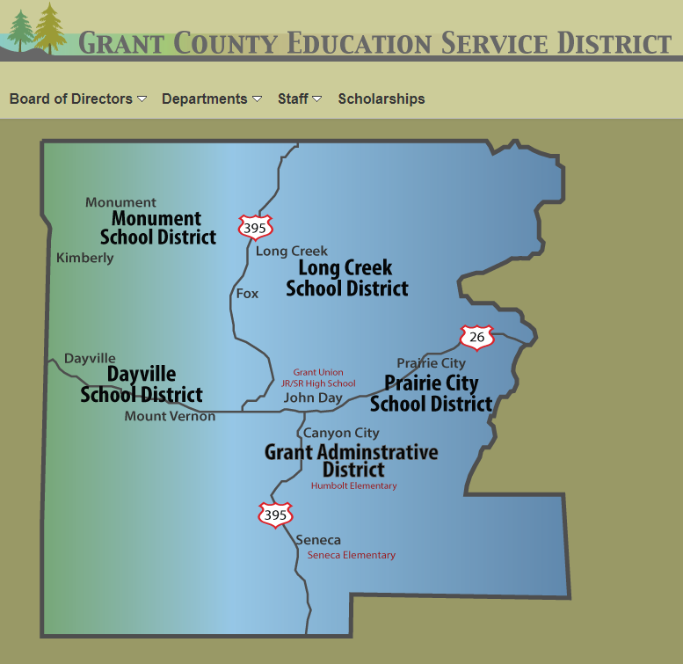

OR

